Lecture 3
Distributed Objects

Introduction

So far, we learned how to send and receive messages (strings) in a unicast and multicast systems. We now go over sending and receiving via objects.
Note: Since we are dealing with threads in java I name a process: a program.

3.1 Message Passing versus Distributed Objects

The message passing systems may not be appropriate for complex applications because:
- Processes (programs) in the message passing paradigm are tightly coupled. If the communication between client/server disrupted, then the session cannot continue.
- The message passing paradigm is data-oriented. The processes transfer data to each other.

In the distributed object paradigm, it is the objects that communicate with each other. Since an object contains data values in the instance variables and methods not only a process (program) sends and receives data values a process (program) can also call a method of an object which resides in a program of another website on the internet:

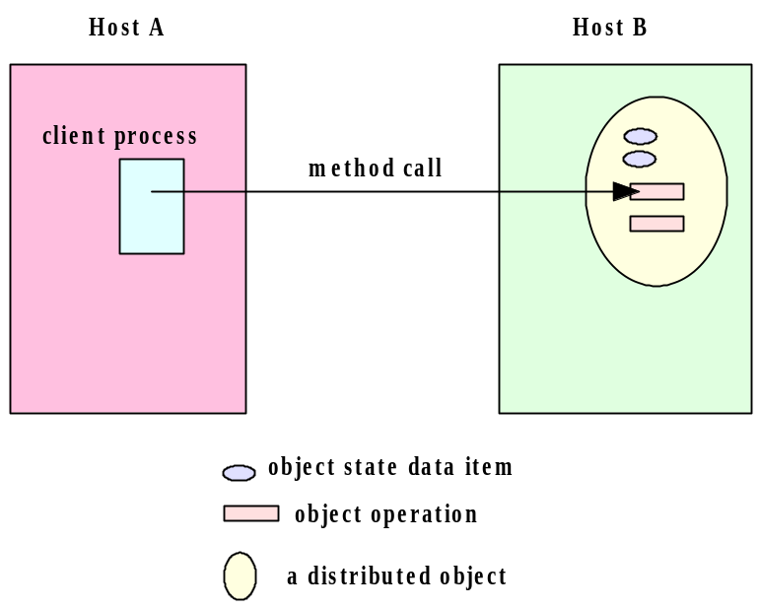
3.2 An Archetypal Distributed Object Architecture

The following figure shows an archetypal distributed object. On the server side the server program creates an object which is called: object server. The object is registered by the (object) registry (A registry is an object on the server side). On the client side the client program creates an object client. The client program then looks at the (object) registry to make sure the object can be referenced. The client object uses this reference to call the methods of the object server. These methods are called remote methods. A call to a remote method is processed by a client proxy which is a software that knows how to communicate with the server proxy. The sever proxy refers to the object server to invoke the method and send the result back to the client proxy. The client proxy in turn gives the result to the object client.

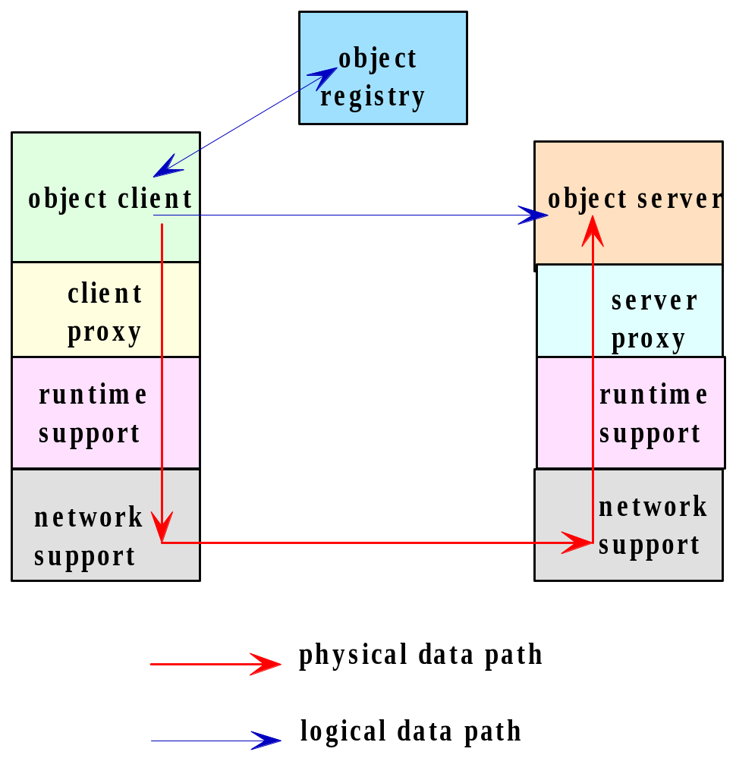

3.3 Distributed Object System

The java programmer use Java Remote Method Invocation (RMI), Common Object Request Broker Architecture (CORBA) and/or the Distributed Component Object Model (DCOM) software for distributed programming. In this and the next chapters, we learn how to use Java RMI and its communication mechanism.

3.4 Remote Procedure Calls

The base of RMI is the Remote Procedure Call (RPC). RPC is used in the procedural programming language like C. The following figure shows how processes over the network call a procedure (function). Process A calls a procedure proc1 that is resided in process B. Process B executes the procedure and sends the return value (if any) to process A. The following figure is more clear and precise. In this figure a process in our computer calls procedure: proc1. This procedure calls procedure: proc2 which is defined on a remote computer. The system executes: proc2 and returns the result to the caller (proc1).

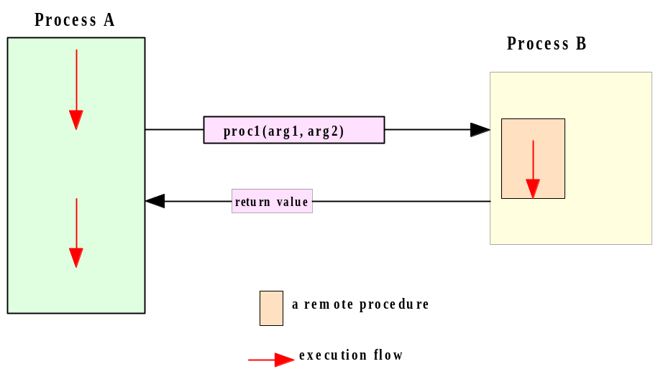

3.5 Remote Method Invocation

RMI is an extension of RPC. In RPC we are dealing with procedures. In RMI we deal with objects. We define a class on the client side to create a client object and a class on the server side to create a server object. We also define an interface. A server class implement the interface. The interface that we define inherits the java interface: Remote. The interface that we define has the signature of some methods that the client can call. The server side implements this interface to define the methods of the interface. The client side does not implement this interface but the interface is available to be used.

3.6 The Java RMI Architecture

The following figure shows the mechanism of a remote call. The client side is on the left and the server side is on the right.
The object client sends a remote method call to its stub (i.e. proxy). The client remote reference layer sends the call to the client transport layer. The transport layer sends the call to the transport layer of the server. This layer sends the call to the server reference layer to interpret for the object server. The server executes the call and sends the result back to the object client.

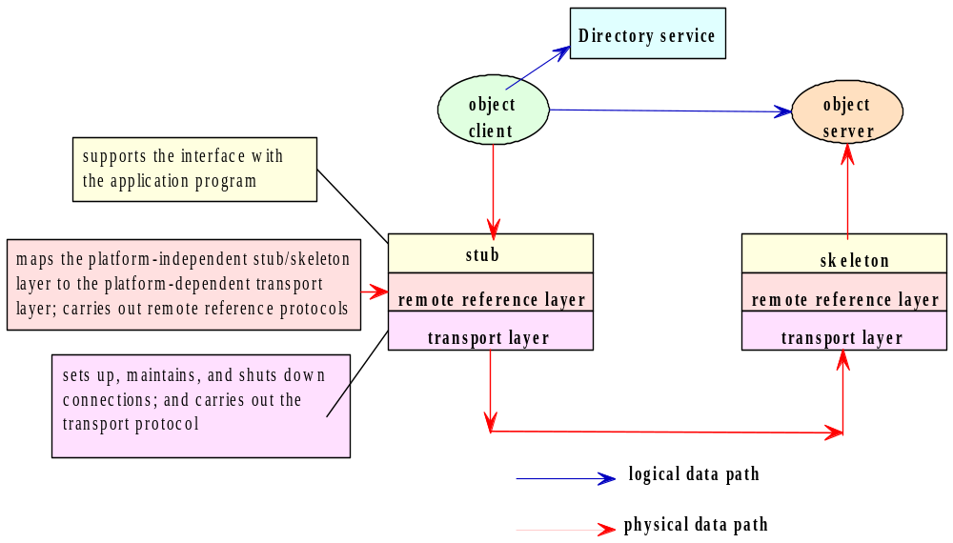

The stub is an object, as a gateway for the client program. When the client program calls a method that is implemented on the server program the stub does the following:

1. Connects to the remote Virtual Machine (JVM),
2. It sends (marshals) the arguments of the method to the remote Virtual Machine (JVM),
3. Waits for the result
4. Reads (unmarshals) the return value
5. Returns the value to the caller.

The skeleton is an object, as a gateway for the server side object. All the incoming requests are routed through it. When the skeleton receives the incoming request, it does the following tasks:

1. Reads the arguments for the remote method
2. Calls the method on the actual remote object
3. Sends (marshals) the result to the caller.

3.7 the API for Java RMI

I explain the API through a simplified version of the client server programs. We need java interface and classes to:

1. Create the remote interface.
2. Use (but not implement) the interface on the client side.
3. Implement the remote interface by a class on the server side.
4. Start the registry service by rmiregistry tool

Note: On the client side we need to define at least one class. On the server side we need to define at least two classes.

Example 1: In the following client-server programs the client calls a method of the server.

The client side class and interface:

import java.rmi.*;
public interface HelloInterface extends Remote {
public String sayHello(String name) throws RemoteException;
}

import java.rmi.*;

public class HelloClient{
public static void main(String args[]){
try{
int port = 16790;
String host = "localhost";
String registryURL = "rmi://" + host + ":" + port + "/hello";
HelloInterface h = (HelloInterface)Naming.lookup(registryURL);
System.out.println("Lookup completed " );
String message = h.sayHello("Donald Duck");
System.out.println("HelloClient: " + message);
}
catch (Exception e){
e.printStackTrace();
}
}
}

The server side classes and interface:

import java.rmi.*;
import java.rmi.registry.LocateRegistry;

public class HelloServer{
public static void main(String args[]){
try{
int port = 16790;
String host = "localhost";
HelloImpl exportedObj = new HelloImpl();
LocateRegistry.createRegistry(port);
String registryURL = "rmi://" + host + ":" + port + "/hello";
Naming.rebind(registryURL, exportedObj);
System.out.println("Hello Server ready.");
}catch (Exception e){
e.printStackTrace();
}
}
}

import java.rmi.*;
import java.rmi.server.*;

public class HelloImpl extends UnicastRemoteObject implements HelloInterface {

public HelloImpl() throws RemoteException {
super( );
}

public String sayHello(String name) throws RemoteException {
return "Hello, World!" + name;
}
}

Description:

The interface:

public interface HelloInterface extends Remote{
public String sayHello(String name) throws RemoteException;
}

This is a java interface. The java class: Remote informs the client that the method: sayHello is implemented remotely (on the server side). This interface is not implemented on the client side.

Note: Since we write all the programs with eclipse you do not have to memorize which exception class should be used here and there. The eclipse tells you which exceptions you need.

Note that this interface is on both the client and server sides. This interface is implemented by the class: HelloImpl on the server side and is not implemented in the client program.

The RMI system has a registry objects. Every remote object must have a name registered in the registry.

The server side:

The class HelloImpl:
- The server creates an object of this class. This object is going to be the remote object. The method: sayHello of this remote object can be called by the client program.

The class HelloServer:
- Method: main:
  - String registryURL = "rmi://" + host + ":" + port + "/hello": This make the string: "rmi://localhost:16790/hello". This string is going to be registered in the registry as the name of the remote object that the variable: exportedObj refers to.
Note: The word: hello is optional. You can change it on both sides to any name.
  - LocateRegistry.createRegistry(port): Creates and exports a registry object on the specified port.
  - Naming.rebind(registryURL, exportedObj): Naming is a class in the package rmi. The method: rebind associates (binds) the above string (blue underlined) with the remote object: exportedObj, which is an object of type class: HelloImpl.

The client side:

The class HelloClient:
- String registryURL = "rmi://" + host + ":" + port + "/hello": This make the string: "rmi://localhost:16790/hello". This string must be in the rmi registry as the name of a remote object. The variable: host is the host where the registry is located. The variable: port is the port number on which the registry on the server side accepts calls. Both host and port are optional. If host is omitted, the host defaults to the local host. If port is omitted, then the port defaults to 1099, the "well-known" port that rmi registry uses.
- HelloInterface h = (HelloInterface)Naming.lookup(registryURL): The method: looks up for the argument (the blue underlined). This name refers to a remote object. Therefore, the variable: h refers to the remote object. Now h can access to any public method and variable of this remote object which is of type class: HelloImpl.
- h.sayHello("Donald Duck"): passes the argument: to the following method. The method returns the string: "Hello, World!Donald Duck".
public String sayHello(String name) throws RemoteException{
return "Hello, World!" + name;
}

Exercise 1: Write a client server program using RMI. The client sends two integers. The server subtract these numbers and sends the result back to the client.

The RMI handles any type of data.

Example 2: In the example the client sends an array of integers and the server returns the array sorted:

import java.rmi.*;
public interface HelloInterface extends Remote {
public int[] sayHello(int[] a) throws RemoteException;
}

import java.rmi.*;

public class HelloClient{
public static void main(String args[]){
int a[] = {3, 4, 2, 1, 5, 7, 4, 8, 10};
try{
int port = 16790;
String host = "localhost";
String registryURL = "rmi://" + host + ":" + port + "/hello";
HelloInterface h = (HelloInterface)Naming.lookup(registryURL);
System.out.println("Lookup completed " );
int[] message = h.sayHello(a);
for(int i = 0; i < a.length; i++)
System.out.print(message[i] + ", ");
}
catch (Exception e){
e.printStackTrace();
}
}
}

import java.rmi.*;
import java.rmi.registry.LocateRegistry;

public class HelloServer{
public static void main(String args[]){
try{
int port = 16790;
String host = "localhost";
HelloImpl exportedObj = new HelloImpl();
LocateRegistry.createRegistry(port);
String registryURL = "rmi://" + host + ":" + port + "/hello";
Naming.rebind(registryURL, exportedObj);
System.out.println("Hello Server ready.");
}catch (Exception e){
e.printStackTrace();
}
}
}

import java.rmi.*;
import java.rmi.server.*;

public class HelloImpl extends UnicastRemoteObject implements HelloInterface {

public HelloImpl() throws RemoteException {
super( );
}

public int[] sayHello(int[] a) throws RemoteException {
for(int i = 0; i < a.length; i++) {
int smallestIndex = i;
for(int j = i + 1; j < a.length; j++)
if(a[smallestIndex]> a[j])
smallestIndex = j;
int temp = a[i];
a[i] = a[smallestIndex];
a[smallestIndex] = temp;
}
return a;
}
}

Exercise 2: Write a client server program using RMI for a bank account. Use the following interface and do not change it. Follow the comments for the description of this exercise.
import java.rmi.Remote;
import java.rmi.RemoteException;

public interface AccountInterface extends Remote {
//In creating an account, it is the bank that selects an account number. In
//our project the first new account is 100, the next is 101, next is 102, ...
//Anyone can open a new account. It does not matter if the person has already accounts. public String createAccount(String name, float balance) throws RemoteException;

//If the name with accountNo is in the bank return the person balance as a string.
//otherwise either name has no account or his account no is wrong.
public String getBalance(String name, int accountNo) throws RemoteException;

// The account number with the name must be in the bank.
// There is not enough fund return to the user a message.
// There is enough funds. Withdraw and return the new balance.
public String withdraw(String name, float amt, int accountNo)throws RemoteException;

// The account number with the name must be in the bank.
// If account number with the name is in the bank, deposit and return the new balance.
public String deposit(String name, float amt, int accountNo) throws RemoteException;

// Both account numbers with the same name must be in the bank.
// There is not enough fund in the account that is goind to transfer return to the user a message.
// There is enough funds. Withdraw and return the new balance.
public String transfer(String name, int fromAccount, int toAccount, float amt) throws RemoteException;
}

